|  |  |
| --- | --- |
| **Computer Science 1** | **Lab 06B**  **Practice/Perform Major Python Assignment** |
| **The Graphics Library Program** | **50, 60, 70, 80, 90, 100 & 110 Point Versions** |
| **Assignment Purpose:**  The purpose of this program is to demonstrate knowledge of calling, and using correct argument passing with several of the procedures from the **Graphics** library. | |

Write a program, which displays several geometric designs using the provided **Graphics** library. This is your first Practice/Perform lab. You will have 1 day to *practice* this assignment. On the practice day you can ask questions and get help. Then you need to *perform*. On this day you need to do the lab, from scratch, for a grade – with no help. Some teachers call this “The Day of Reckoning”.

Whether practicing or performing, you will be provided with a skeleton program. Your job is to use the proper procedures from the **Graphics** library along with the correct argument values to match the output shown on this assignment. Students are allowed to refer to the **Graphics Library Reference** document while practicing AND when they do the lab for a grade. In fact, students may refer to this document during any lab and any test. The first couple pages of the document are shown below. The entire document can be found in the **IntroCS-Graphics Files** subfolder of your **LearnIntroCS** folder.

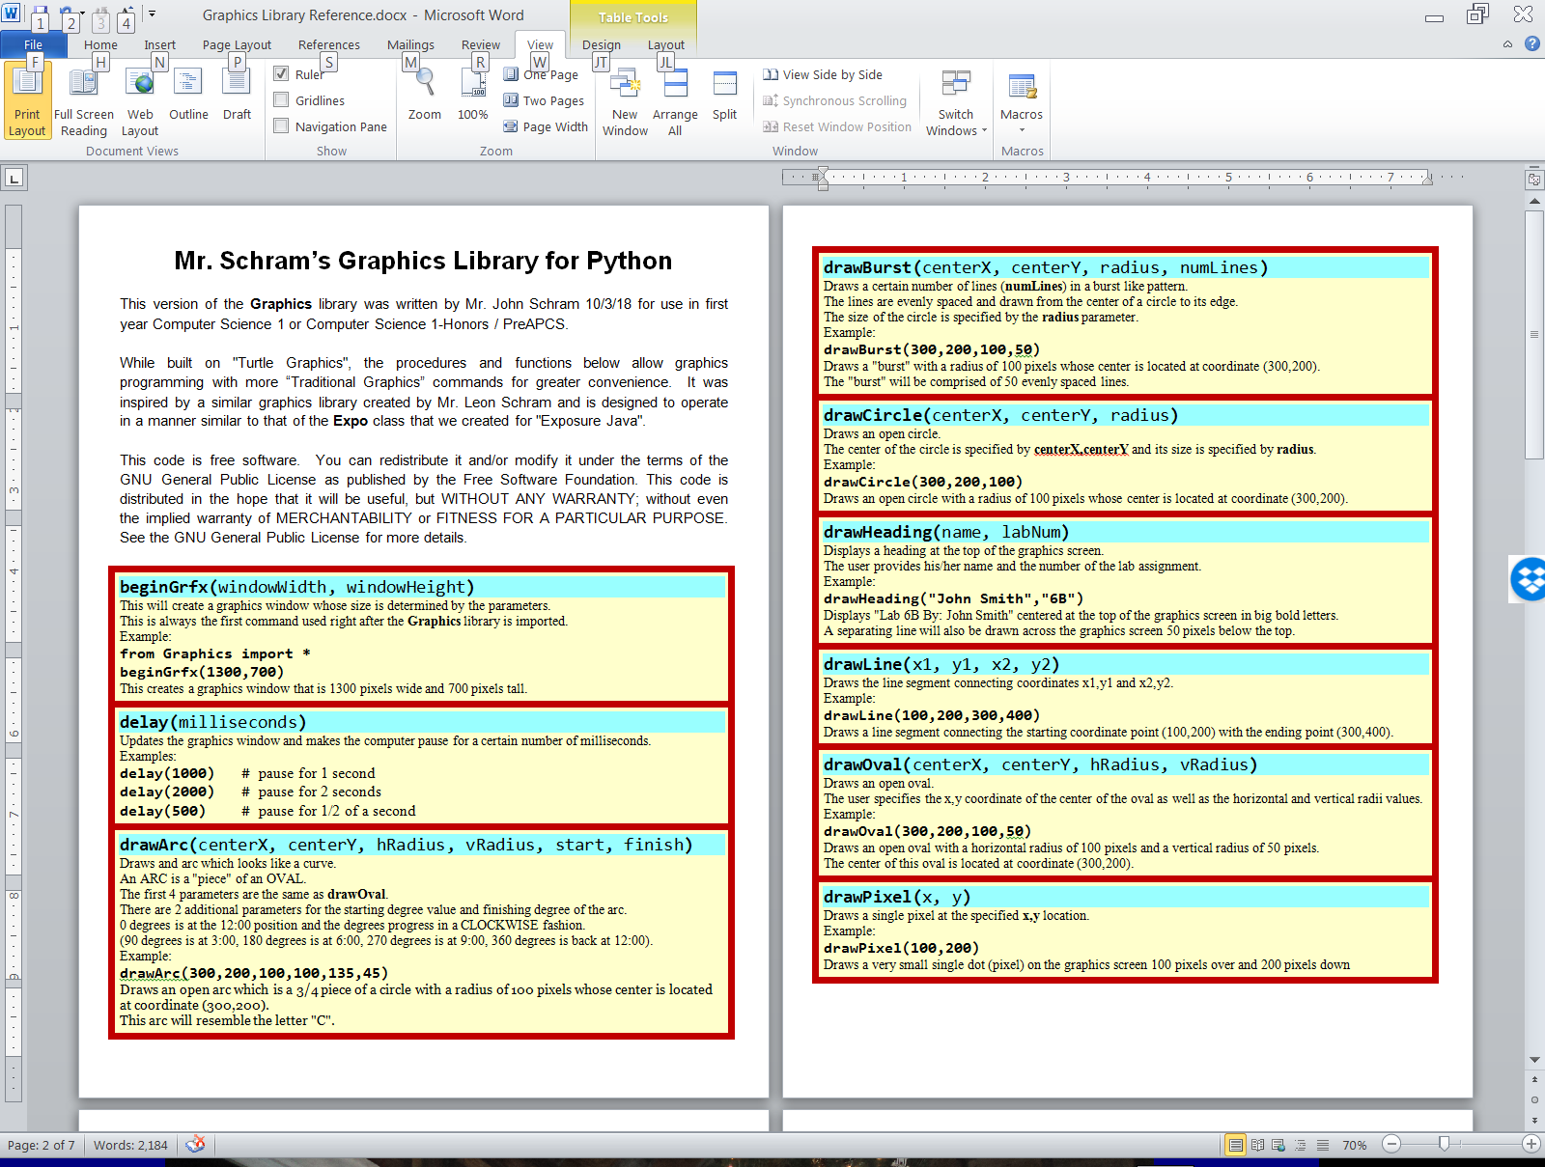

|  |  |
| --- | --- |
| **Lab 06B Student Version** | **Do not copy this file, which is provided.** |
| **1 # Lab06Bst.py  2 # "The Graphics Library Program"  3 # This is the student, starting version of Lab 06B.  4   5   6 from Graphics import *  7   8 beginGrfx(1300,700)  9  10 # Substitute your own name here. 11 drawHeading("John Smith","6B") 12  13  14 # DRAW CUBE 15  16  17  18 # DRAW TARGET 19  20  21  22 # DRAW 7-SIDED DESIGN 23  24  25  26 # DRAW STOPLIGHT 27  28  29  30 # DRAW JPIIHS 31  32  33  34 # DRAW SMILEY FACE 35  36  37  38 # DRAW WEIRD TRIANGLE 39  40  41  42  43 endGrfx() 44** | |

**50, 60, 70, 80, 90, 100 and 110 Point Versions**

The 50-point version displays any 1 of the 7 pictures below.

The 60-point version displays any 2 of the 7 pictures below.

The 70-point version displays any 3 of the 7 pictures below.

The 80-point version displays any 4 of the 7 pictures below.

The 90-point version displays any 5 of the 7 pictures below.

The 100-point version displays any 6 of the 7 pictures below.

The 110-point version displays ALL 7 pictures below.

NOTE

The pictures do not need to look exactly as they appear below. They should be very similar.

They also should not overlap with any other picture.

The *Target* must have 5 *concentric circles*. The spacing between all the circles should be the same.

The *7-Sided-Design* is made by placing a black 7-point burst on top of a white 7-point filled star on top of a black 7-sided filled regular polygon.

The *Face* should be made up of 3 *ovals*, 3 *arcs* and 2 *points*.

In the *Triangle*, each of the 3 *interior lines* connects a *corner* to the *midpoint* of the line segment on the opposite side. The triangle does not need to be *equilateral*, but it does need to be *isosceles*.

